**Budget Line of the Consumer | Microeconomics**

The budget line is a boundary line because the consumer has to operate under two constraints, viz., limited money income (called income constraint) and fixed prices of purchasable goods (called price constraint). If the consumer’s income is unlimited he does not face any choice problem.

And the consumer is assumed to a price taker and a quantity adjuster. He cannot alter the market price of any of the purchasable goods by buying a little more or a little less of it.

**The Desire or the Capacity to Buy:**

The budget line shows the consumer’s purchasing (buying) power, i.e., what he can afford with his fixed income at prevailing market prices.

The indifference map of our representative consumer (which is a set of all his indifference curves) is a nice way of summarizing his taste and preferences. It shows what he is willing to buy (or desirous of buying). The truth is what that there is no point in knowing a consumer’s desire when he has no capacity to buy his desirable bundle of consumption goods.

If the consumer is assumed to buy only two goods say x1 and x2, where x1 may be bread and x2 may be money (or all other goods). Thus with fixed income any purchase involves a trade-off. If more x1 is bought, the consumer is left with less money to buy all other goods.

So this assumption makes good sense and should not be treated as unrealistic. We make this assumption just to be able to depict the consumer’s choice behaviour graphically.

[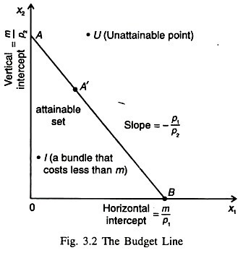](http://www.microeconomicsnotes.com/wp-content/uploads/2017/12/clip_image004_thumb4_thumb.jpg)

**The budget constraint of the consumer is composed of the following three items:**

ADVERTISEMENTS:

**1. Consumption Bundle:**

Let us indicate our representative consumer’s consumption bundle by (x1, x2). This is just a list (combination) of two numbers indicating how much the consumer is choosing to consume of any two goods — x1 and x2.

**2. Prices:**

ADVERTISEMENTS:

Let the market prices of the two goods be p1 and p2. These prices are taken as fixed by an individual consumer.

**3. Money Income:**

Finally we denote the fixed money income of the consumer by m. We are not interested in analysing the rational (optimising) behaviour of a consumer whose money income is unlimited because he has not to face any real choice problem.